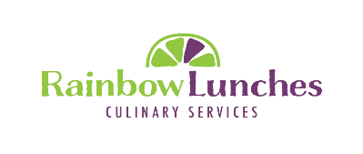

**November Cycle**

Menu selections for your school can now be viewed on line

Please visit [www.rainbowlunches.com](http://www.rainbowlunches.com) to place your order

ORDERS MUST BE PLACED BY MIDNIGHT: Friday October 19th, 2018

Please Note: Order Form CANNOT be accessed after the deadline has passed!

*A $2 (per child) surcharge will be added for late submissions*

**4316 Ebenezer Road – Side Door**

**Brampton, Ontario, L6P 0R9**

**416.617.5369**

[**info@rainbowlunches.com**](mailto:info@rainbowlunches.com)

[**www.rainbowlunches.com**](http://www.rainbowlunches.com)

Instagram: @rainbow_lunches

**Rainbow Lunch Orders Notification**

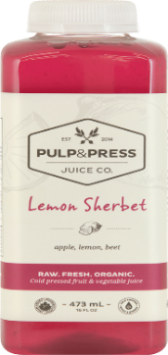

**New Chicken Strips will be served - as of Tuesday October 9th**

**Please share your feedback!**

We’ve partnered with Pulp & Press to be able to offer you the highest quality COLD PRESSED FRUIT & VEGETABLE JUICE

Pulp & Press uses an industrial grade hydraulic cold press juicer, the highest quality juice press that exists, to extract the optimal amount of nutrients and enzymes from 100% organic fruits and vegetables.

Promises greater energy, clearer mindset and glowing skin.

Available Varieties: Lemon Sherbet, Spicy Lemon, Turbo

Our soft cookies have always been PPM150 compliant but now they are even better! Same great taste but now with more fiber and less sugar than previous versions.

Dairy, Egg, Sesame and Nut FREE!

**Product Highlights:**

**Things to Remember:**

1. Order forms are sent out on a monthly basis offering 4 weeks of lunches per cycle (all the dates offered within a cycle DO NOT necessarily fall within the same month)

|  |  |
| --- | --- |
| **Order Cycle** | **Date Range Coverage** |
| September/October | September 10 to October 26, 2018 |
| November | October 29 to November 23, 2018 |
| December/January | November 26, 2018 to February 1, 2019 |
| February | February 4 to March 1, 2019 |
| March | March 4 to April 5, 2019 |
| April | April 8 to May 3, 2019 |
| May | May 8 to May 31, 2019 |
| June | June 3 to June 28, 2019 |

1. If you are new to our system, you will need to create an account by following the on-screen prompts. Returning clients can click on “Create Order” to begin the process.
2. We are committed to providing your children with hot wholesome foods, delivered right to their classroom at lunch hour and it is crucial that your child’s classroom information is up to date.
3. If your child is ill please **CALL US: 416.617.5369** - before 8:30AM to cancel the meal.
4. Please contact us to discuss any dietary preferences or special requests your child may have (Vegetarian, Gluten Free, modifications etc.)

rainbowlunches.com | [info@rainbowlunches.com](mailto:info@rainbowlunches.com) | @rainbow_lunches | 416.617.5369